**Project Design Phase-II**

**Data Flow Diagram & User Stories**

|  |  |
| --- | --- |
| Date | 25 June 2025 |
| Team ID | LTVIP2025TMID30212 |
| Project Name | SmartSDLC – AI-enhanced Software Development Lifecycle |
| Maximum Marks | 4 Marks |

**Data Flow Diagrams:**

A Data Flow Diagram (DFD) is a traditional visual representation of the information flows within a system. A neat and clear DFD can depict the right amount of the system requirement graphically. It shows how data enters and leaves the system, what changes the information, and where data is stored.

**Example:** [**(Simplified)**](https://developer.ibm.com/patterns/visualize-unstructured-text/)

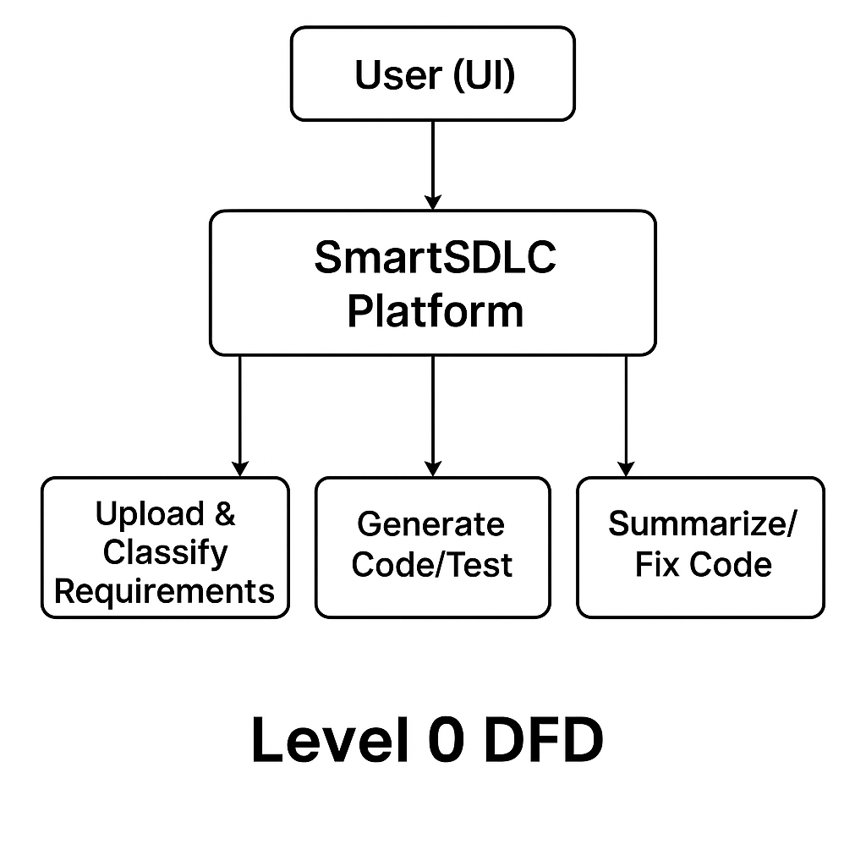

**User Stories**

Use the below template to list all the user stories for the product.

| **User Type** | **Functional Requirement (Epic)** | **User Story Number** | **User Story / Task** | **Acceptance criteria** | **Priority** | **Release** |
| --- | --- | --- | --- | --- | --- | --- |
| Customer (Web user) | Requirement Classification | USN-1 | As a user, I can upload a PDF and get classified SDLC phases for each requirement. | Each line from PDF is tagged into one of SDLC stages (Req, Design, Dev, Test, Deploy). | High | Sprint-1 |
| Customer (Web user) | Code Generation | USN-2 | As a user, I can provide a prompt and receive auto-generated Python code. | Functional, clean code generated for prompt. | High | Sprint-1 |
| Customer (Web user) | Test Case Generation | USN-3 | As a user, I can get test cases for input code using AI | pytest/unittest-style tests are shown. | Medium | Sprint-1 |
| Customer (Web user) | Bug Fixing | USN-4 | As a user, I can submit buggy code and get a corrected version. | Cleaned code is returned. | High | Sprint-2 |
| Customer (Web user) | Code Summarization | USN-5 | |  | | --- | |  |  |  | | --- | | As a user, I can input code and receive a human-readable explanation. | | Clear explanation and summary of logic returned. | Medium | Sprint-2 |
| Customer (Web user) | Chat Assistant | USN-6 | As a user, I can ask queries about SDLC or AI and get real-time answers. | Bot responds contextually using LangChain. | Medium | Sprint-2 |
| Customer (Web user) | Feedback Form | USN-7 | As a user, I can submit my feedback from the app. | Message is accepted and stored/displayed. | Low | Sprint-3 |
| Customer (Web user) | Dashboard UI Navigation | USN-8 | As a user, I can navigate between features via a clean interface. | Buttons/cards redirect to respective modules. | Medium | Sprint-3 |
|  |  |  |  |  |  |  |
|  |  |  |  |  |  |  |
|  |  |  |  |  |  |  |
|  |  |  |  |  |  |  |